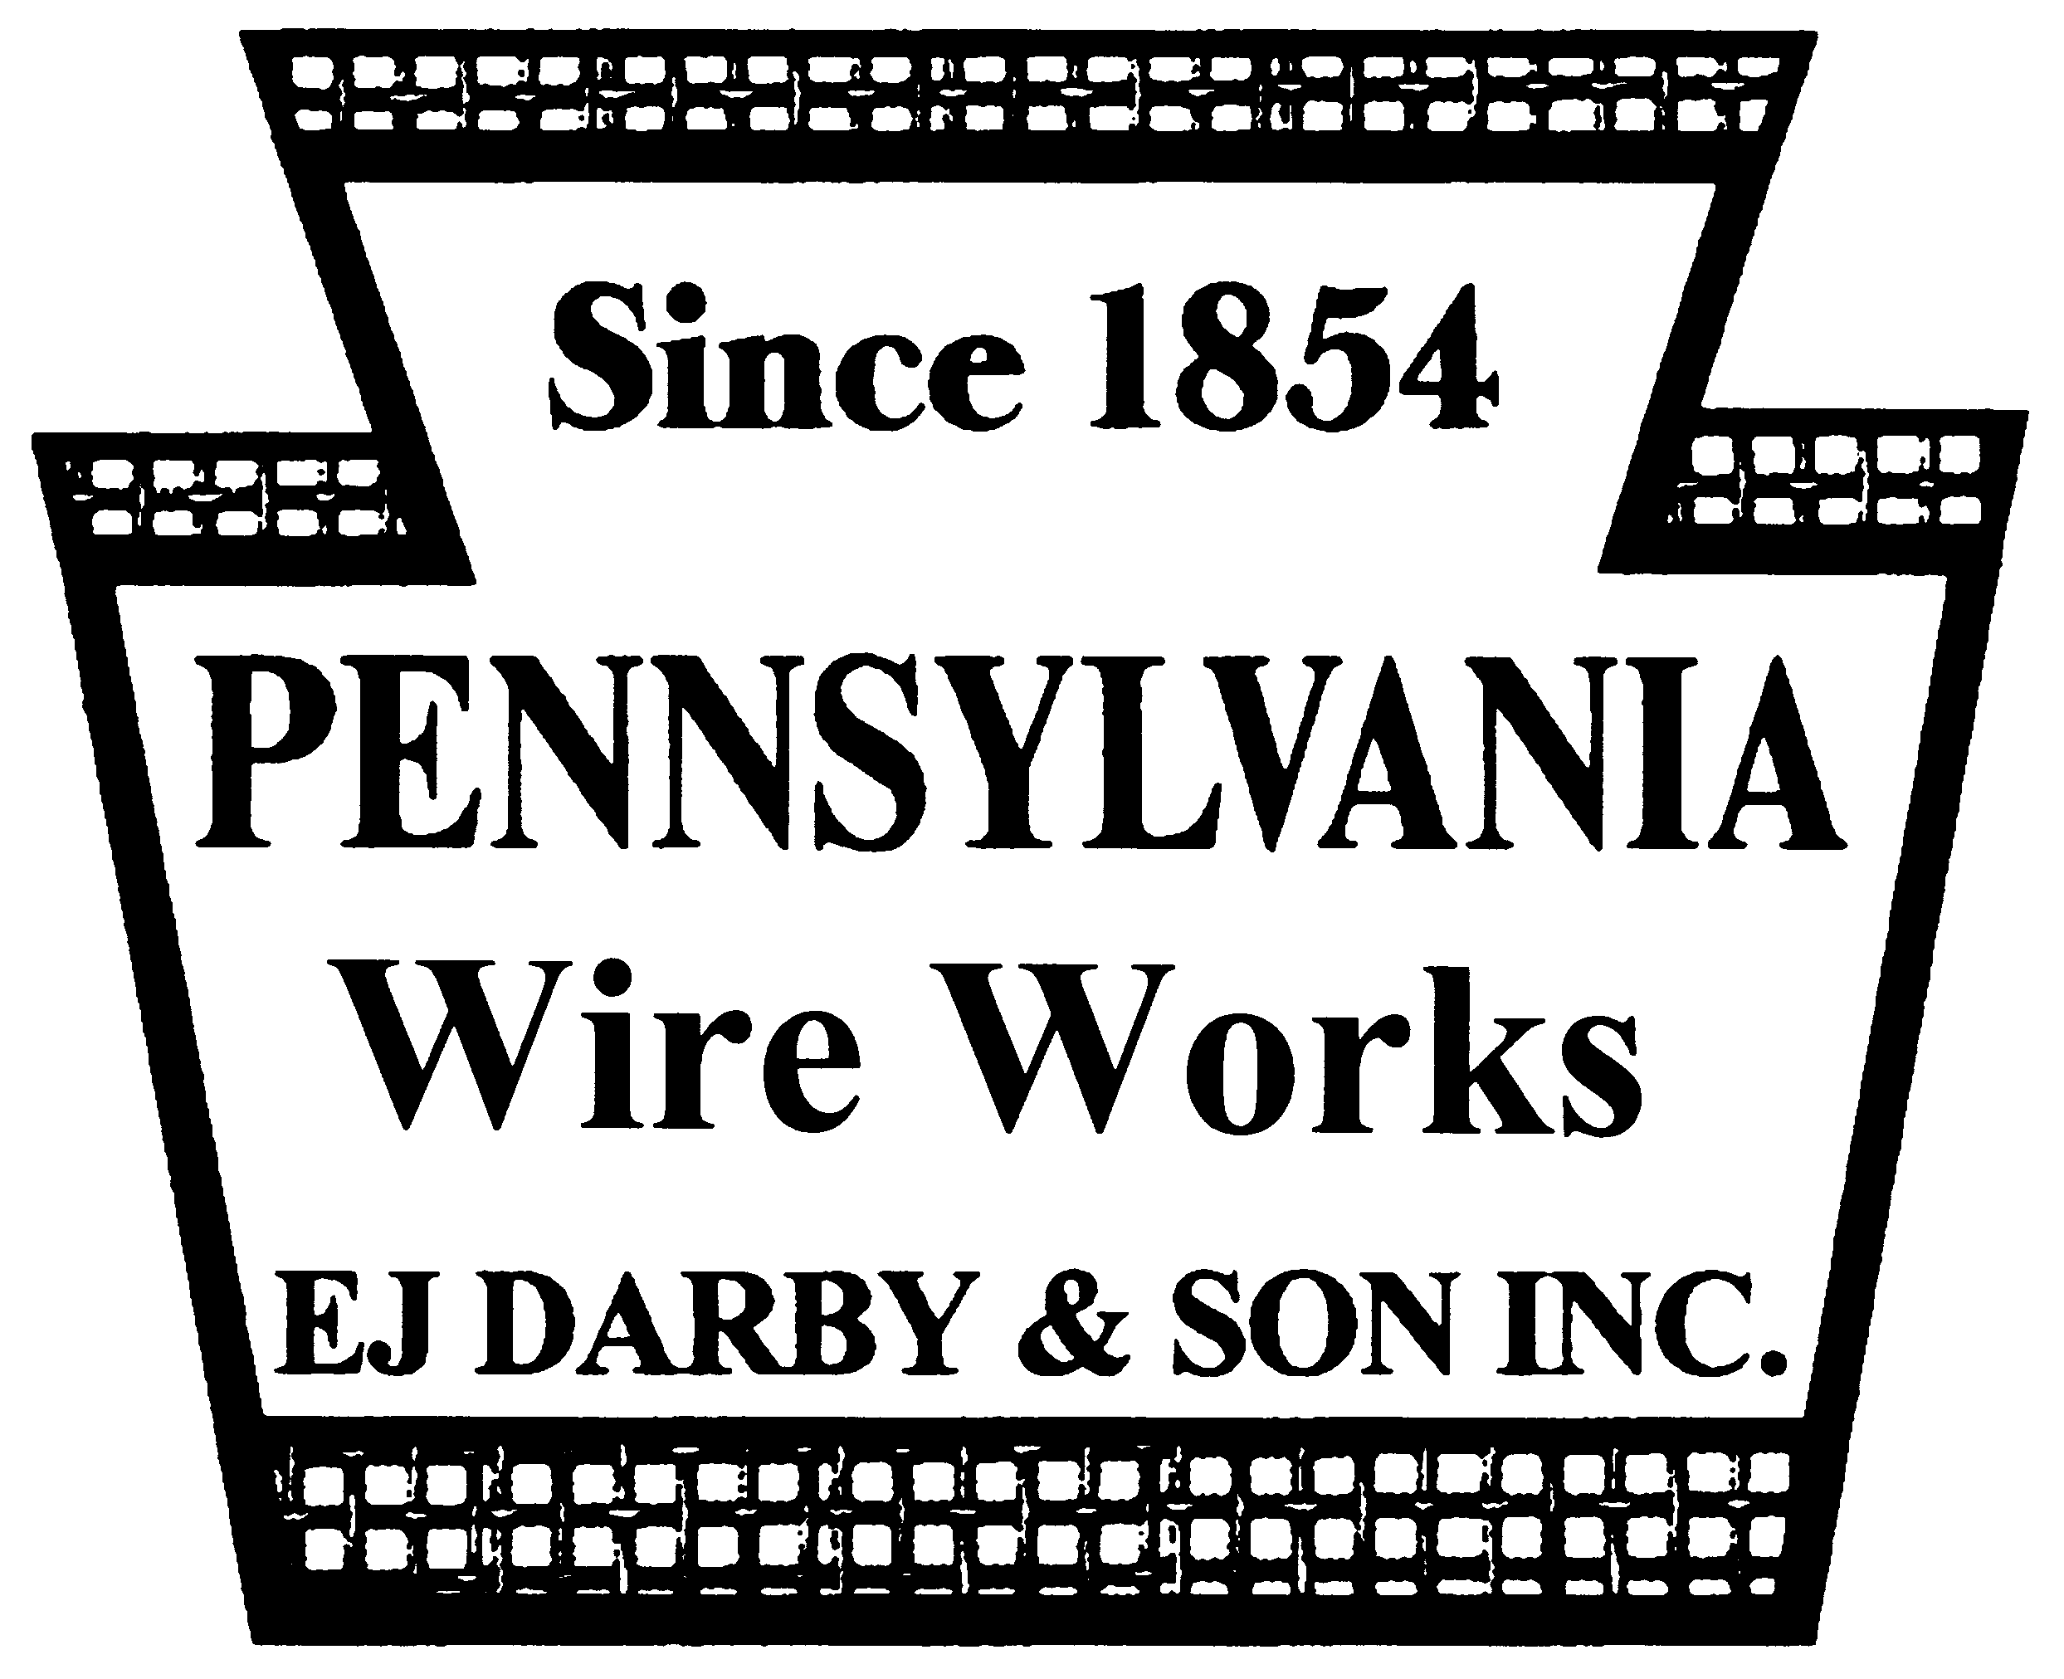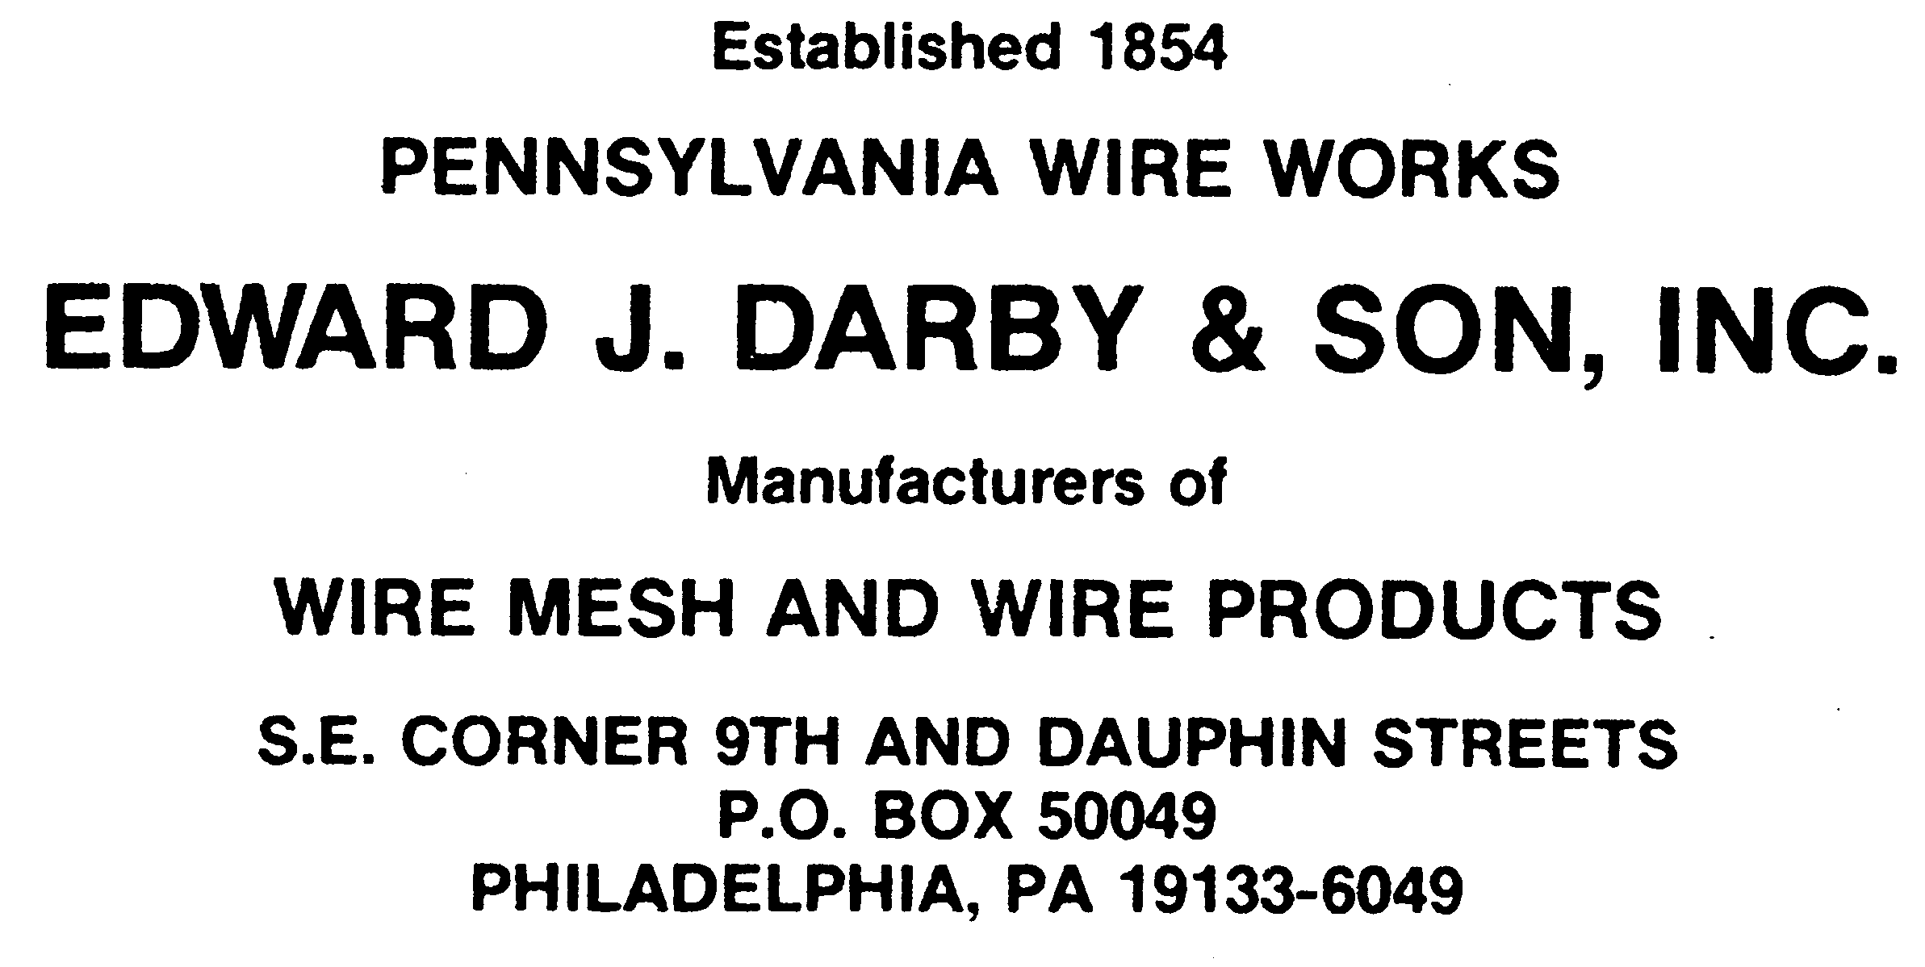 (800) 875-6374
(215) 236-2203
FAX: (215) 236-9989
darbywire@aol.com
www.darbywire.com

July 29, 2026

DECLARATION OF CONFORMANCE REACH -SVHC

Dear Valued Customer,

Edward J Darby & Son, Inc certifies that all of our wire mesh items are compliant with the European Union Regulation (EC) 1907/2006 governing the Registration, Evaluation, Authorization and Restriction of Chemicals (REACH) and do not contain substances above 0.1% weight of a Substance of Very High Concern (SVHC) listed in Annex XIV as of June 15, 2019.

Under the definition of the REACH regulations EC1907/2006, Edward J Darby & Son, Inc is a producer of “articles”. REACH requires article suppliers to inform recipients if an article contains a Substance of Very High Concern (SVHC) in excess of 0.1% by weight. The EU announced on June 15th, 2019 an updated list of the candidate 197 SVHC chemicals. The list can be found at: http://echa.europa.eu/chem_data/authorisation_process/candidate_list_table_en.asp In addition to changes made in Annex XVII fall within this list of SVHC: Per COMMISSION REGULATION (EU) No 276/2010 of 31 March 2010

Based on the material content certifications provided by Edward J Darby & Son, Inc’s suppliers, none of these substances are present in the materials we use in our products, including packing and shipping materials. Therefore, Edward J Darby & Son, Inc products do not contain any of these SVHC in excess of 0.1% by weight. Edward J Darby & Son, Inc will continue to comply with REACH requirements and notify customers of any change in article content.

Edward J. Darby & Son, Inc.
2200 N. 8th St
PO Box 50049
Philadelphia, PA 19133
(800) 875-6374
darbywire@aol.com

