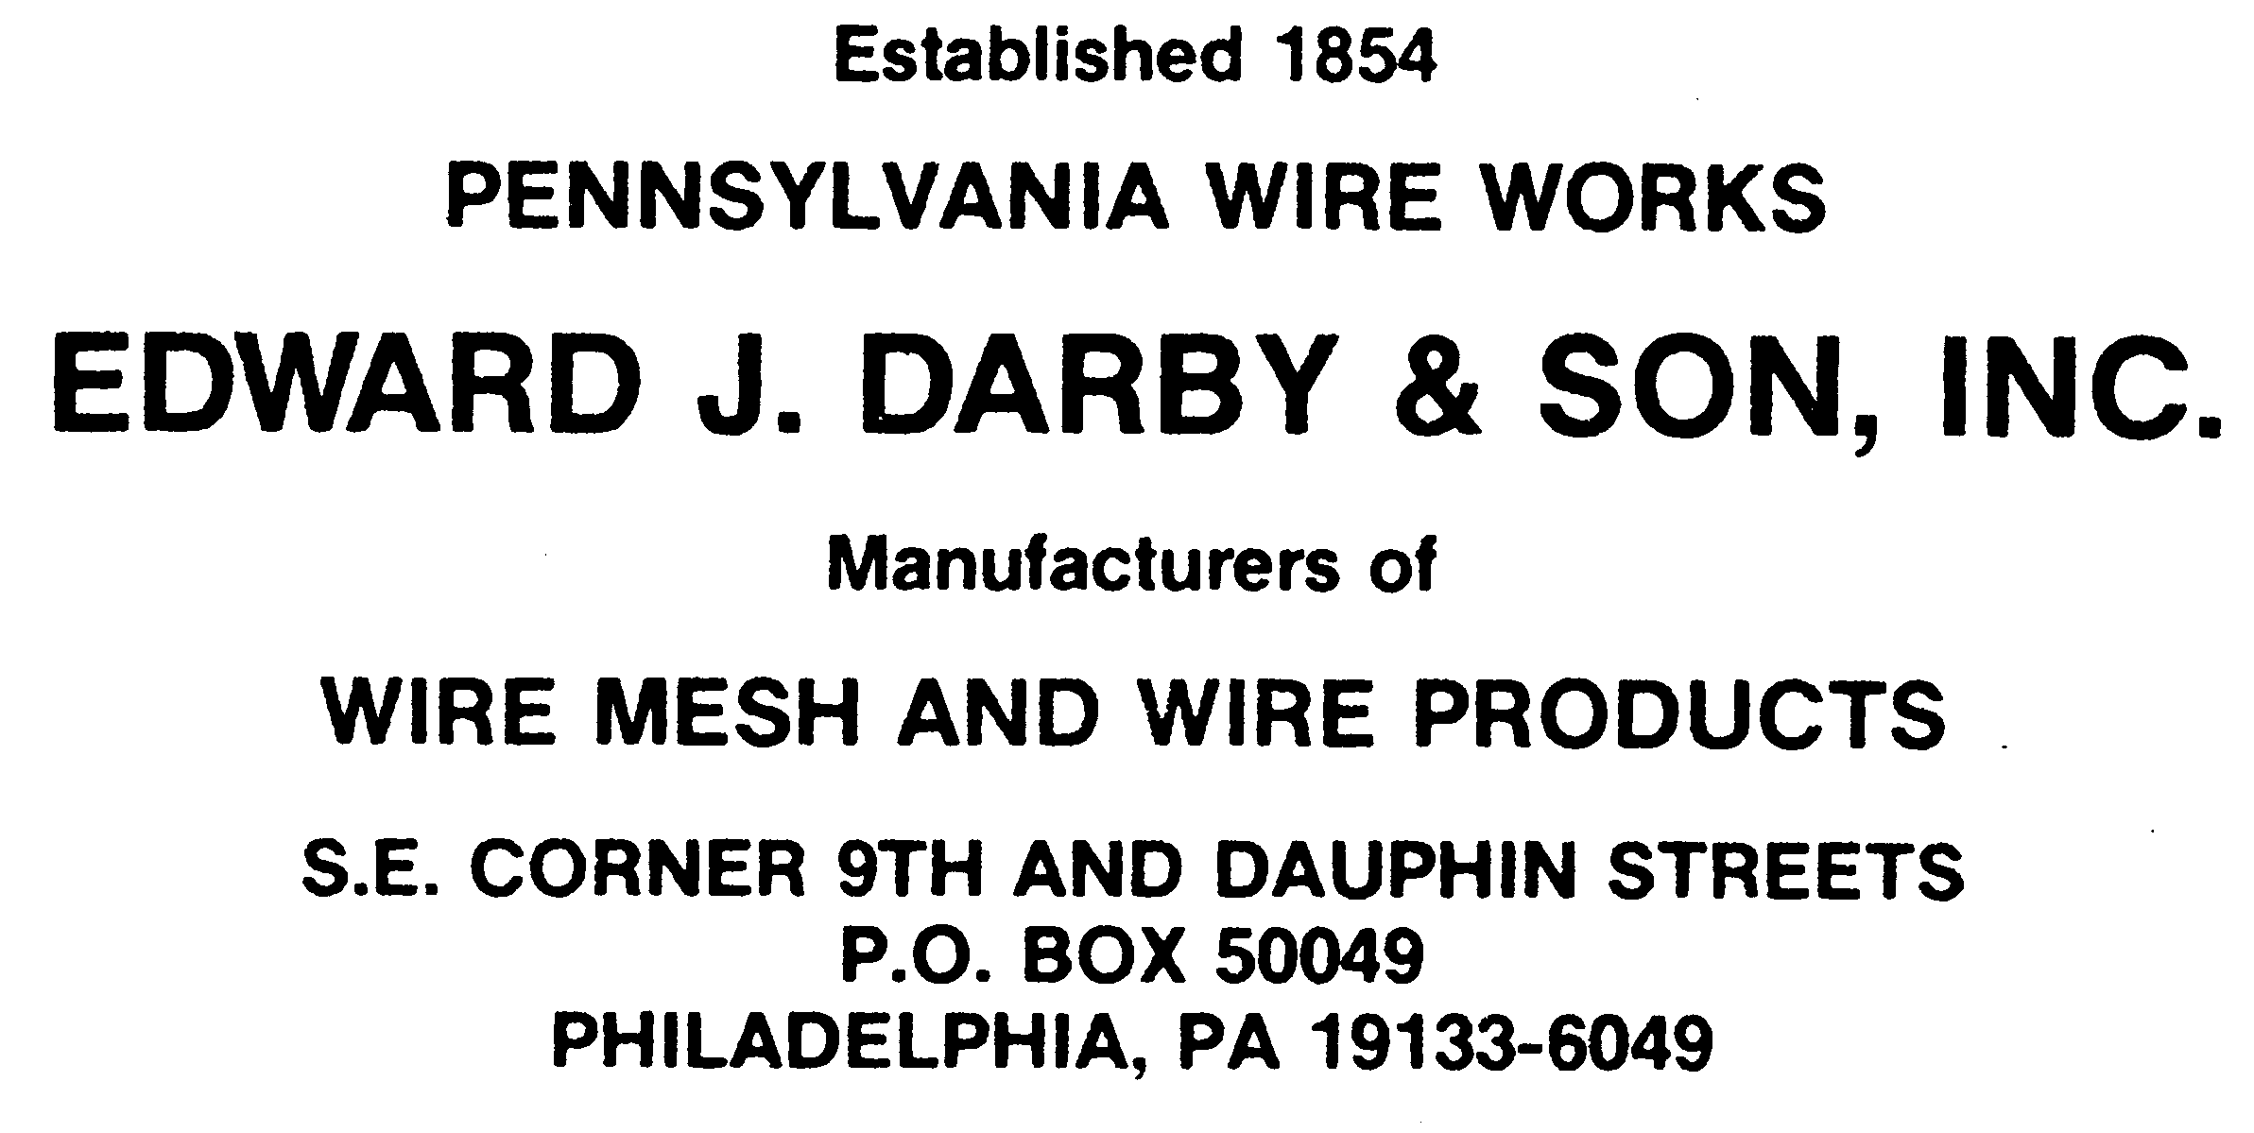 (800) 875-6374
(215) 236-2203
FAX: (215) 236-9989
darbywire@aol.com
www.darbywire.com

July 29, 2026

RoHS Compliance Statement

Edward J Darby & Son, Inc (Darby) certifies that wire mesh products supplied by Darby are in compliance with, and conform to, the European Union's Restriction of Use of Hazardous Substances in Electrical and Electronic Equipment (RoHS) Directive 2002/95/EC, 2011/65/EU (RoHS2), and 2015/863 (RoHS 3).

Said products have no intentional addition of:
* Cadmium (Cd): < 100 ppm
* Lead (Pb): < 1000 ppm
* Mercury (Hg): < 1000 ppm
* Hexavalent Chromium: (Cr VI) < 1000 ppm
* Polybrominated Biphenyls (PBB): < 1000 ppm
* Polybrominated Diphenyl Ethers (PBDE): < 1000 ppm
* Bis(2-Ethylhexyl) phthalate (DEHP): < 1000 ppm
* Benzyl butyl phthalate (BBP): < 1000 ppm
* Dibutyl phthalate (DBP): < 1000 ppm
* Diisobutyl phthalate (DIBP): < 1000 ppm

Any trace impurities of these substances are below the threshold limits as specified by the RoHS directive.

This declaration is based on our vendor supplied analysis and material certifications of the component materials used in the manufacturing of our products. Darby believes to the best of its knowledge that the above statements are accurate as of the date of this certification and the statements and certifications of suppliers or service providers that Darby may have relied upon in the preparation of this statement. Within the above defined limitations this certificate may be relied upon by the distributors and customers of products supplied by Darby.

Edward J. Darby & Son, Inc.
2200 N. 8th St
PO Box 50049
Philadelphia, PA 19133
(800) 875-6374
darbywire@aol.com

